Desired learning outcome: “Design and implement a prototype dynamic web site incorporating database access. “The website created was meant to be a web shop for selling products to customers. In the end, it would have been out of scope, so as an alternative the website was changed to work as a platform for downloading pictures of the products (for logged in users/employees/admin only). The website provides a Login, Registration and Edit Data for every user, employees can additionally use the CRUD operations on the products and the admin has the CRUD operation privilege on the users. A normal user can only see the products and download a specific one and has no rights to change the product data.

Requirements:

1. Existing user should be able to login with username and password:

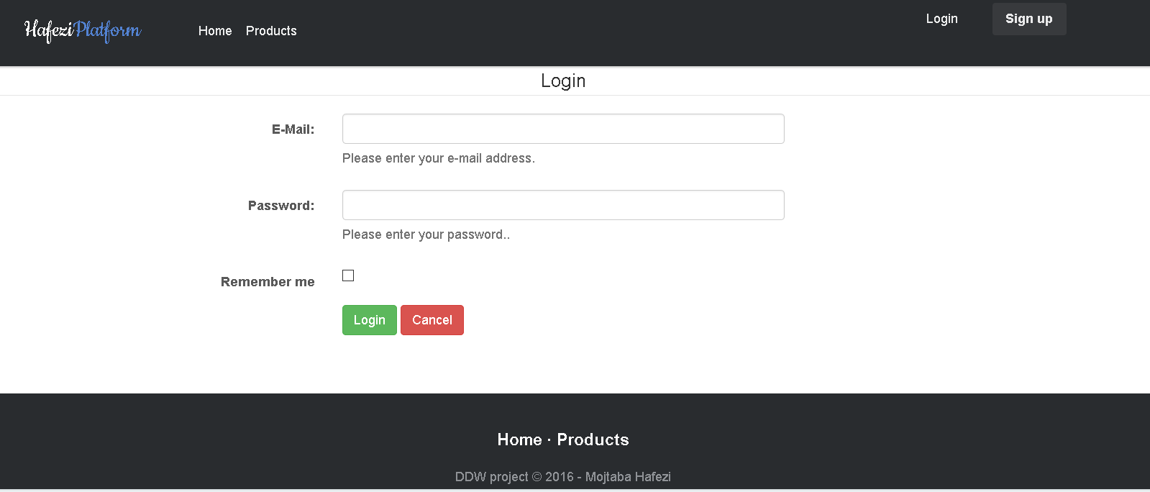

After successful login the user gets redirected to the previous page he came from or the standard page. On the right upper corner one can see the email address used to login – this could easily be changed for a username etc.

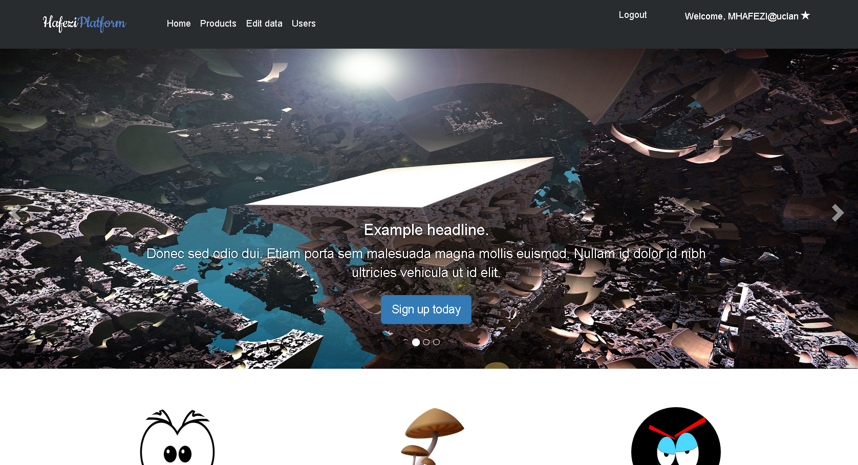

1. Registration of users with username and password:

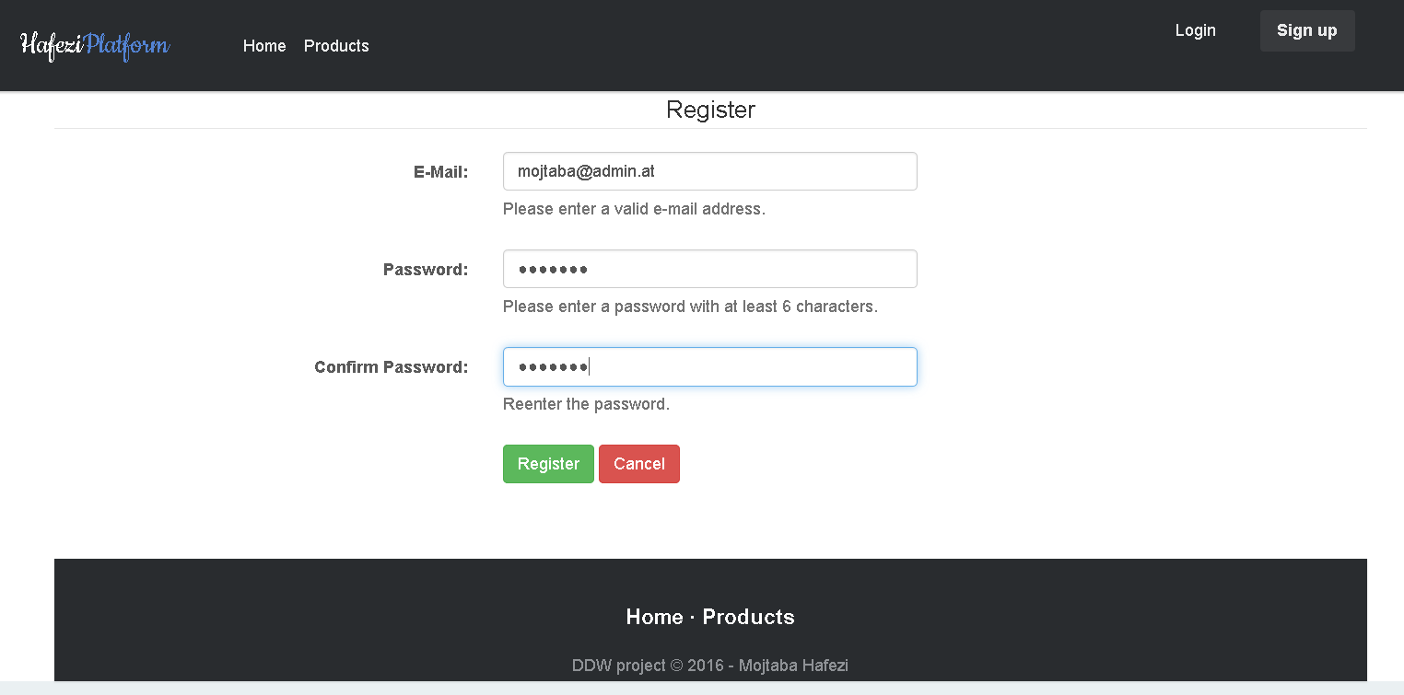

After successful registration the user stays logged in and gets redirected to the homepage.

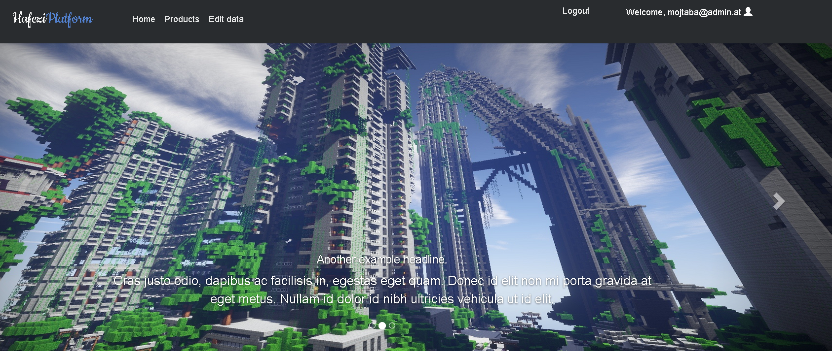

1. Persistent state between pages:

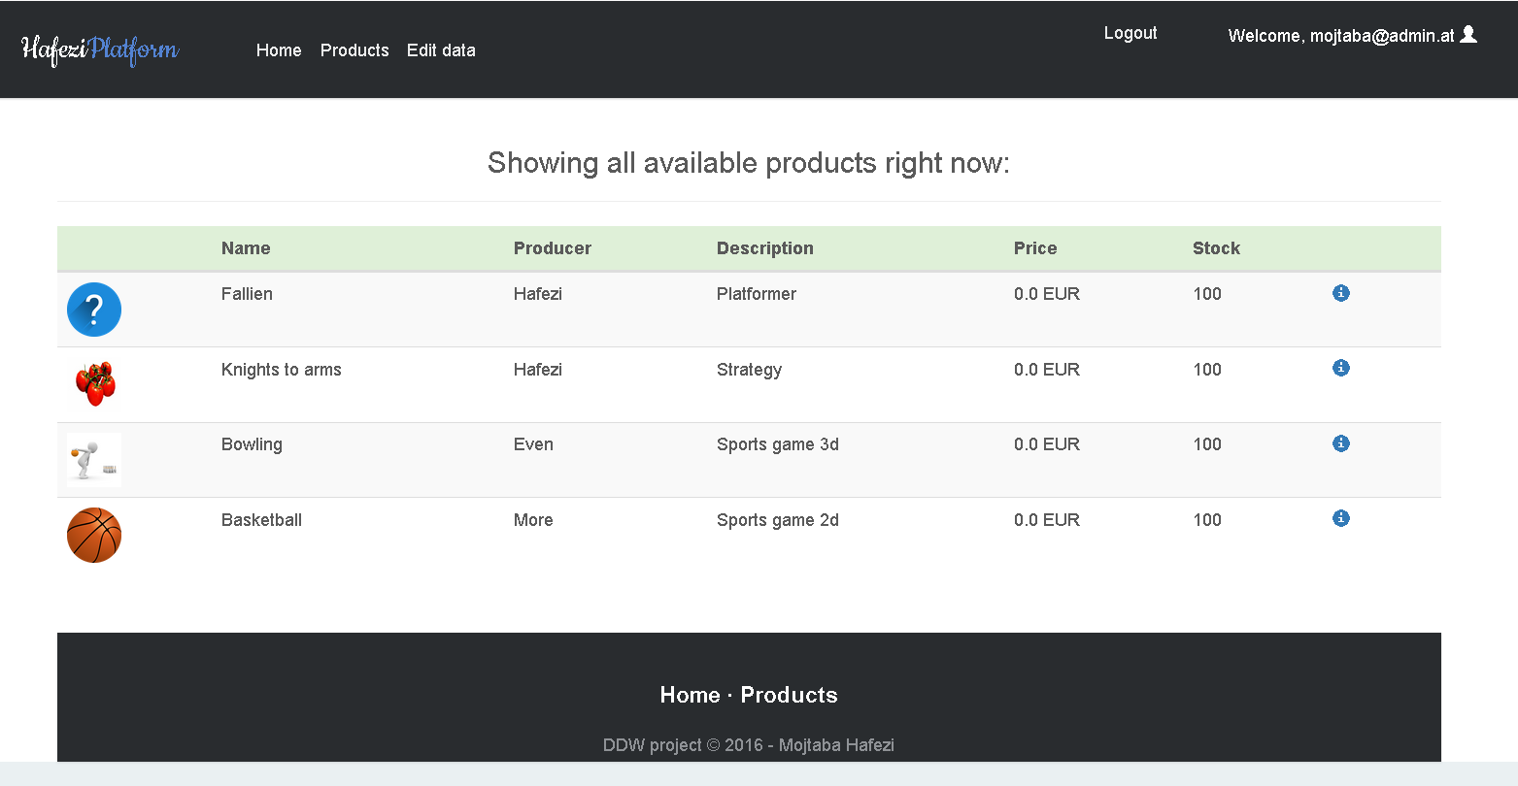



By clicking on the information icon (which only logged in users can see) the user gets forwarded to the detail page where a download function is available to get the picture showing.

1. Minimum of 2 MYSQL tables for data:

The MYSQL database has 2 tables which are user and products. The user contains the email addresses, the hashed password and the role. The products contain more information about the product with the URL to the picture.

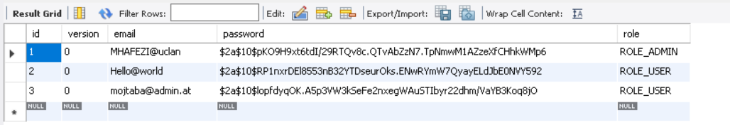

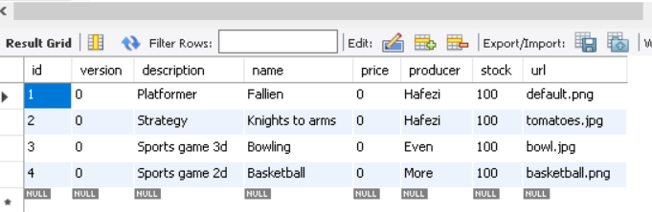

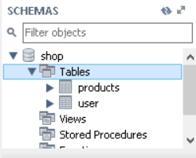

1. No deprecated methods for connections

By using the spring boot application with correct configuration the connection to many databases is possible be it SQL or NOSQL databases.

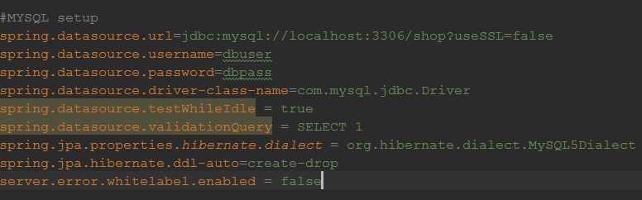

The dependencies must be configured correctly too. As one can see, the SSL is disabled for development process. Furthermore the username and password chosen are not safe.

1. Server and client side validation:

Server validation: By extending the Spring Security validators and adding minor checks the server validation works without problems.

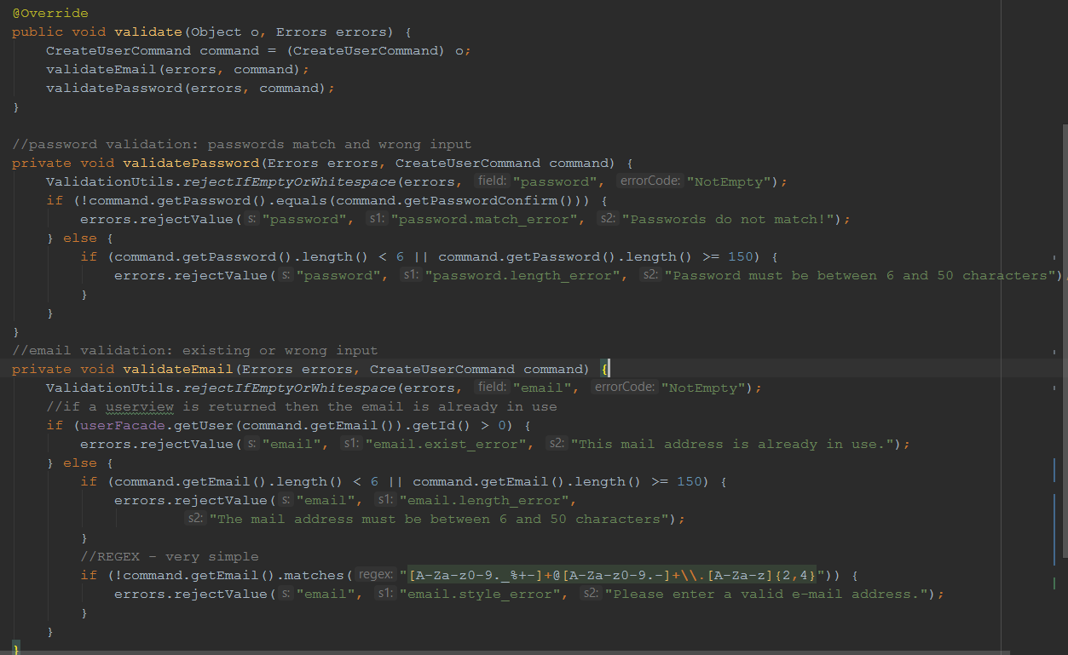

Furthermore, validation also happens on the domain layer with the explicit annotations required. This code catches all problems occurring and forwards it to the BindingResult to provide the information on the views. Different Validators are used for different validation on users and products.

1. CRUD operations on data:

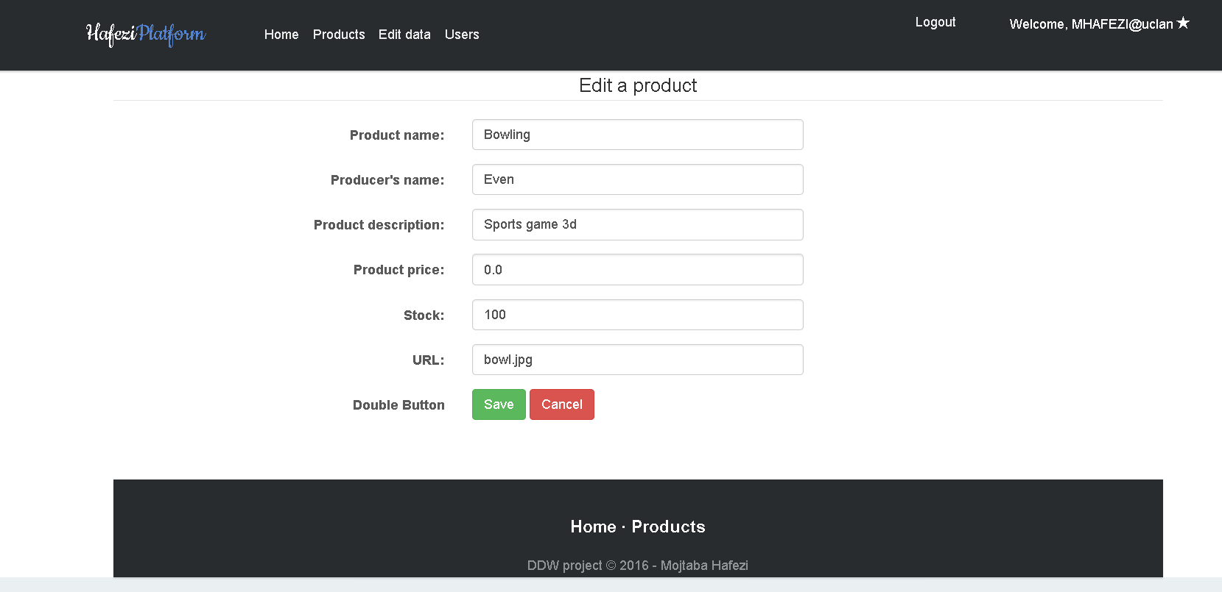

A broad range of information can be changed. The employees and admins can operate all CRUD operations on the products, while the users can only be viewed and changed by the admin.

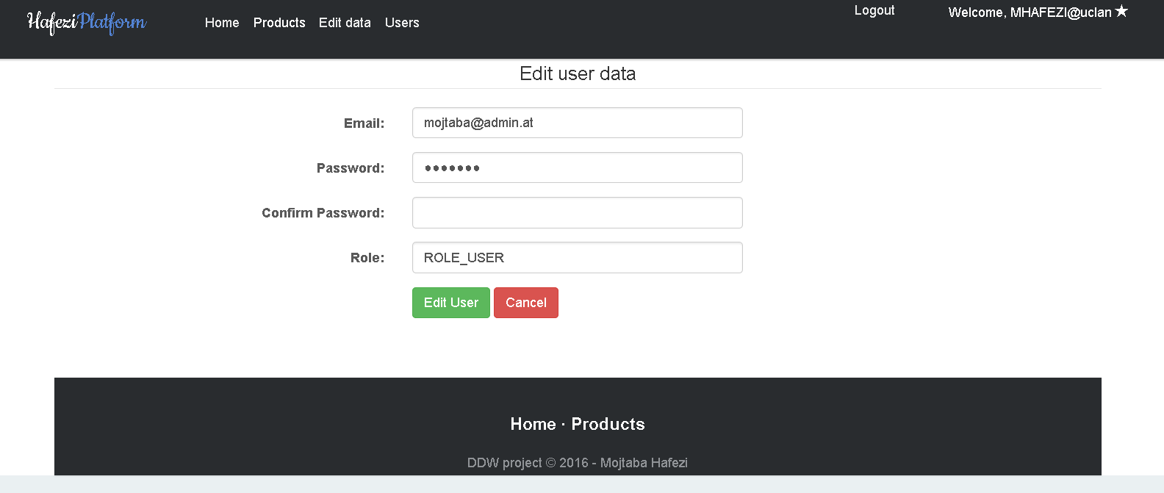

Some of the fields get auto-populated. This is provided mostly through the server but also the html placeholder comes in use (for products for example).

1. Different users with different rights/views:

To begin with I provide three roles: User, Admin and Employee. The employee can change product data and their own user data like password or email. A normal user has no CRUD rights on any data but his own login credentials. The admin has CRUD rights on all tables and can see the list of users etc.

The admin is marked on the upper right corner by a star and the navigation bar shows more options:

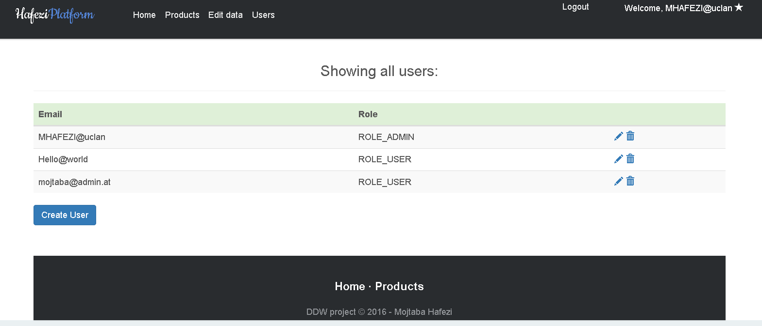

The employee is marked with the sunglasses and has fewer options for changes.

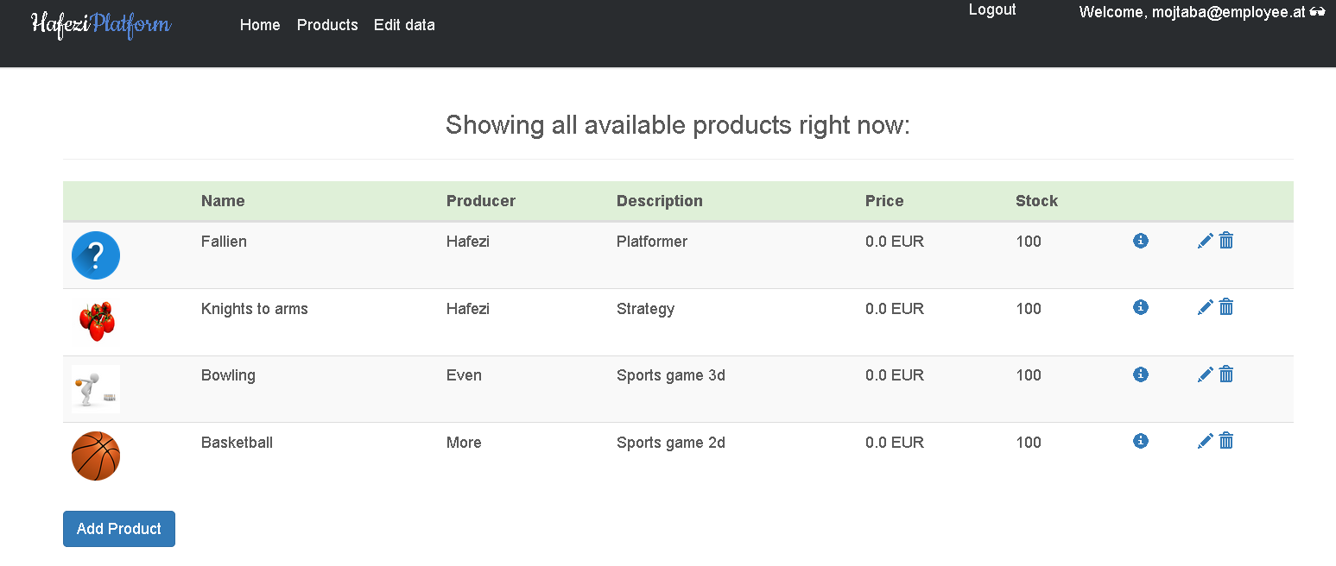

The user marked with a user icon, can only edit his/her own data and view/download the products.

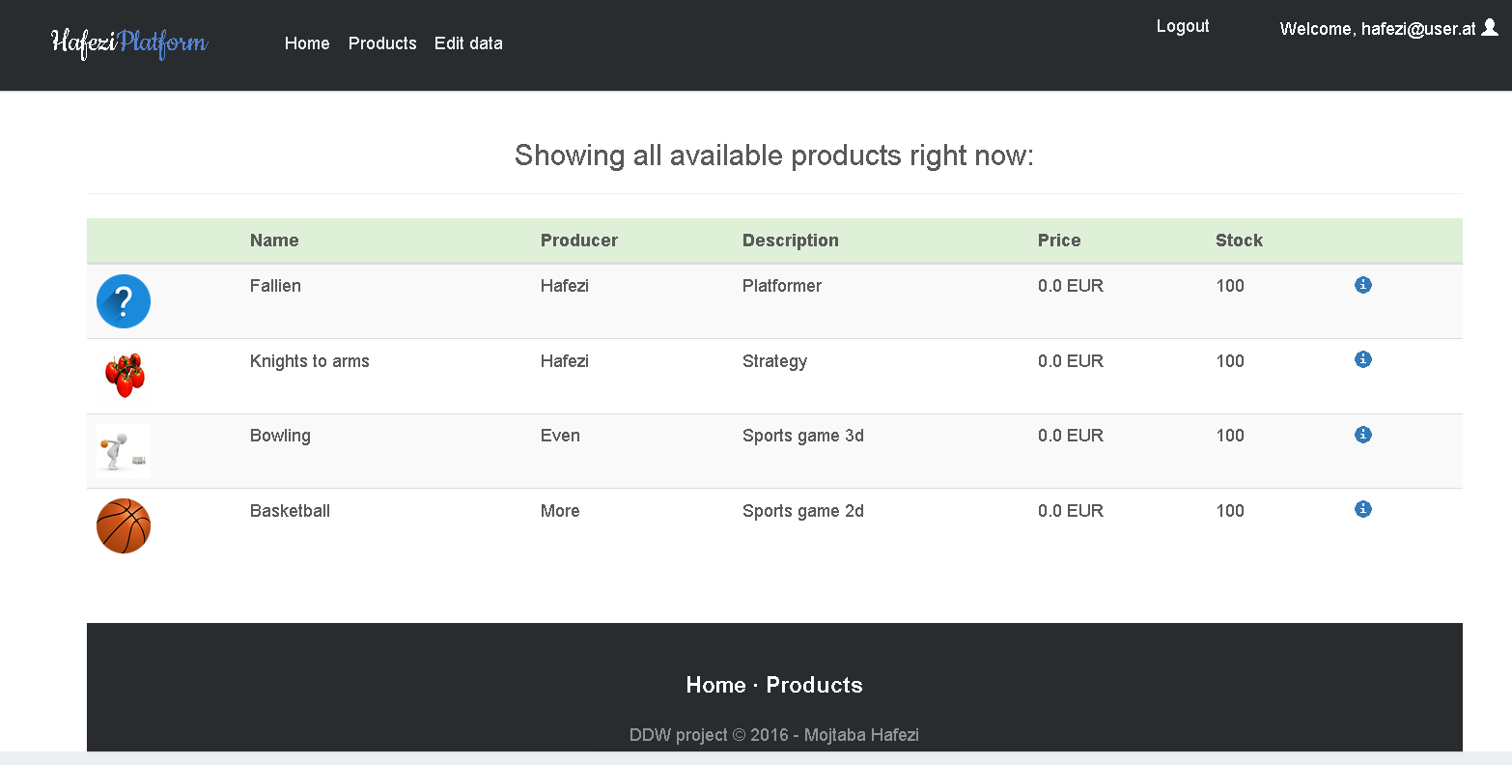

1. Secure password hashing with additional salting:

After researching many hashing algorithms and possibilities in java I came to the conclusion to use the BCrypt hashing algorithm. It has a salting function, which makes the passwords very safe. There is no way to decode the hashed algorithm so the match function gets used to check for correctness of the passwords. CSRF_Token was also enabled for better protection.

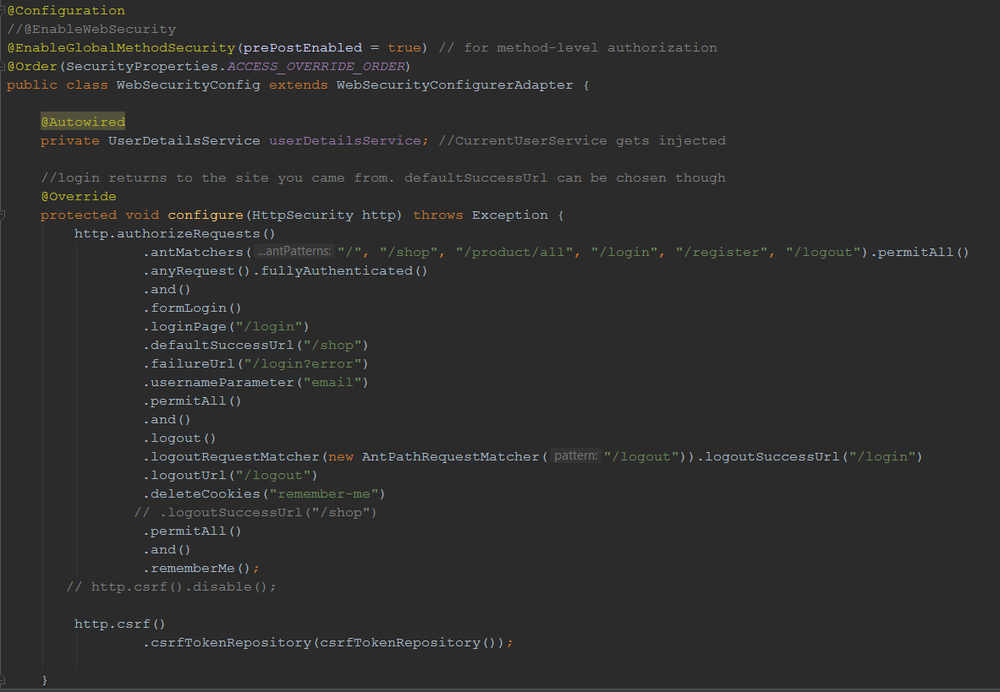

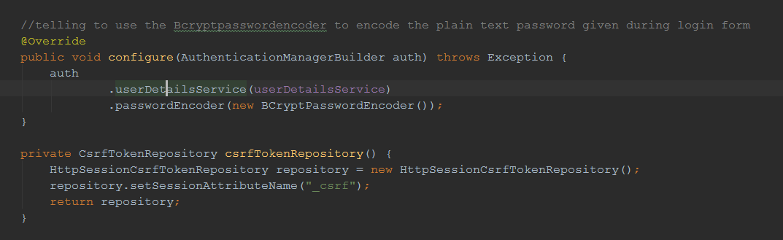

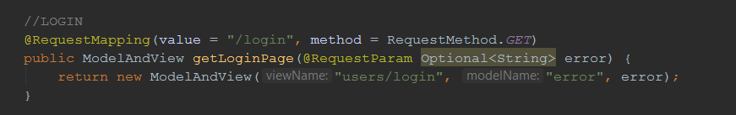

Login Process: The user opens the /login URL and fills up the form to submit it. Meanwhile the LoginController returned a view with the form and after submitting the data the loadUserByUsername() gets called by the UserDetailsService (which I implemented with the CurrentUserService class). The username (as in the configuration shown equals the email) is given to the load method and the CurrentUser is returned from the Service layer. Afterwards the getPassword() method gets called and the comparison with the saved hashed password happens with the matches() method of the BCryptPasswordEncoder class. If any problems occur, the URL is set to login?error where the message “Username or Email is wrong”. The actual problem is not visible to make it more secure against intruders. Further details can be viewed in the code section.

1. Additional security features:

To prevent Cross-site request forgery a CSRF token is created in a cookie, which is deleted after the user logs out again. To make this possible, proper HTTP verbs like GET and POST are used through the complete website. Using the configure method in the WEBSECURITYCONFIG class the application ensures any request to the application requires authentication for specific URLS and allows form based login. Furthermore, the logout is handled by invalidating the session, deleting cookies and redirecting to the login page.

1. Additional performance feature:

Caching enabled for specific methods of the repository (get all users for example etc.). Furthermore, by using sprites the performance can be increased a lot. I provided these for the three background images used in the carousel of the home page. By adding all three backgrounds in one picture and using css to determine where each background starts, not only are all three pictures loaded by one single HTTP call but also reduces the overhead and bandwidth used.

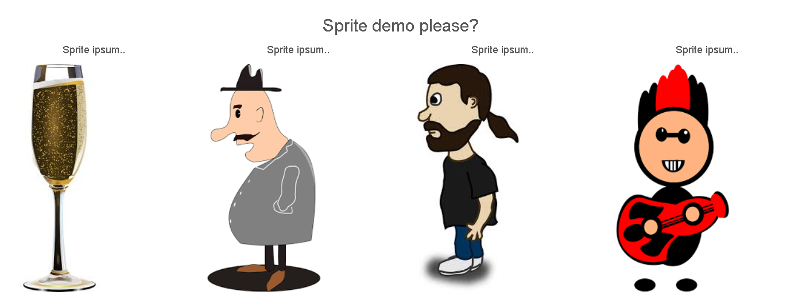

Depending on the images used and the sprite created the performance increase differs. In this example the sprite is about 120KB bigger in size but reduces the calls needed from four to only one.

This can be easily accomplished using css like in the presented demo or special tools.

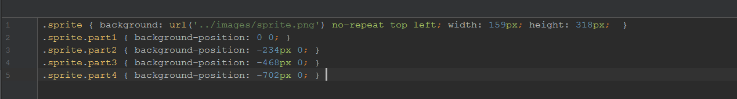

1. Design, usability and layout:

A well designed website is provided with responsiveness and thorough usability. More pictures are added in the appendix.

Appendix A:

Pictures of the website with different logins and views are added for a better overview.

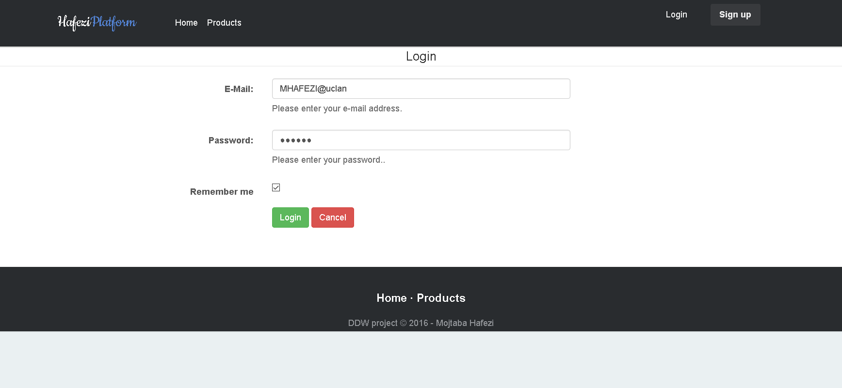

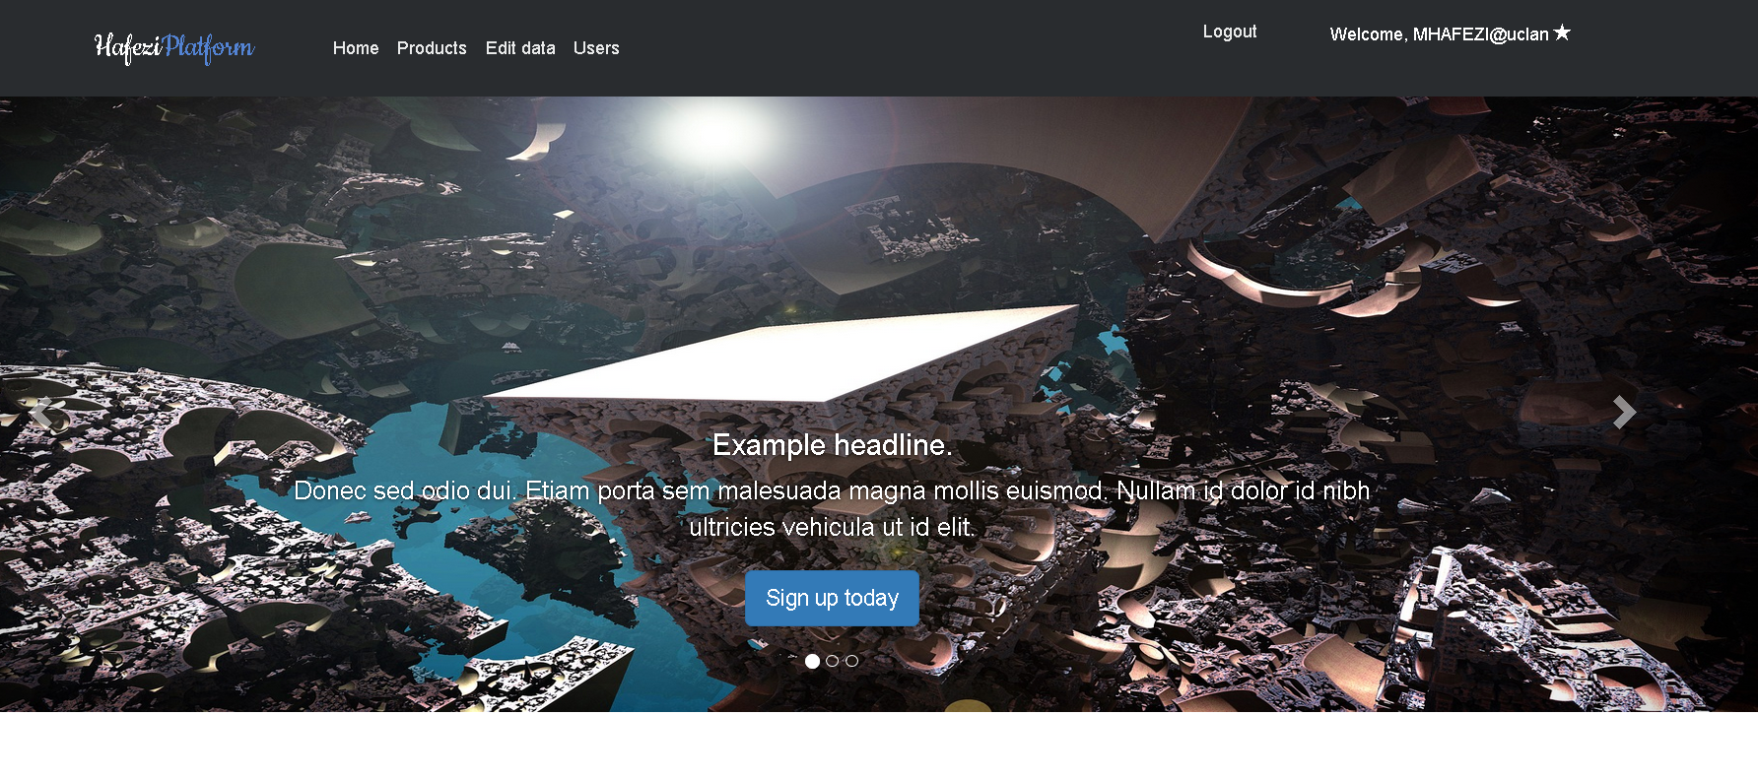

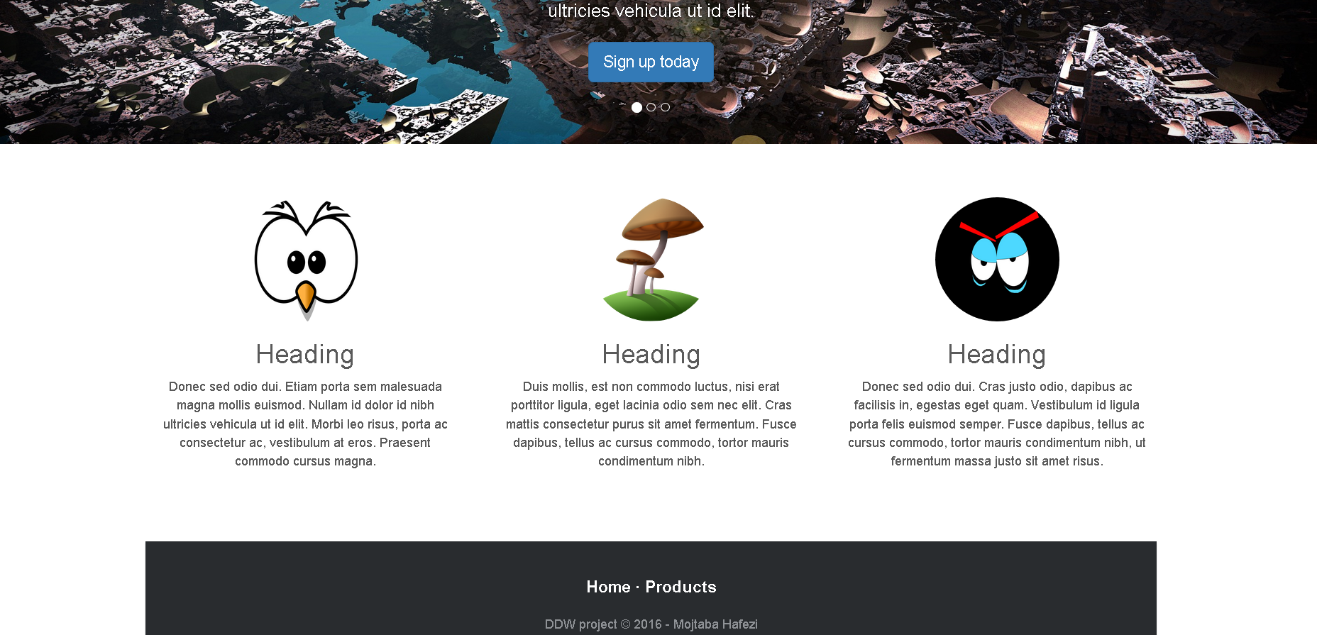

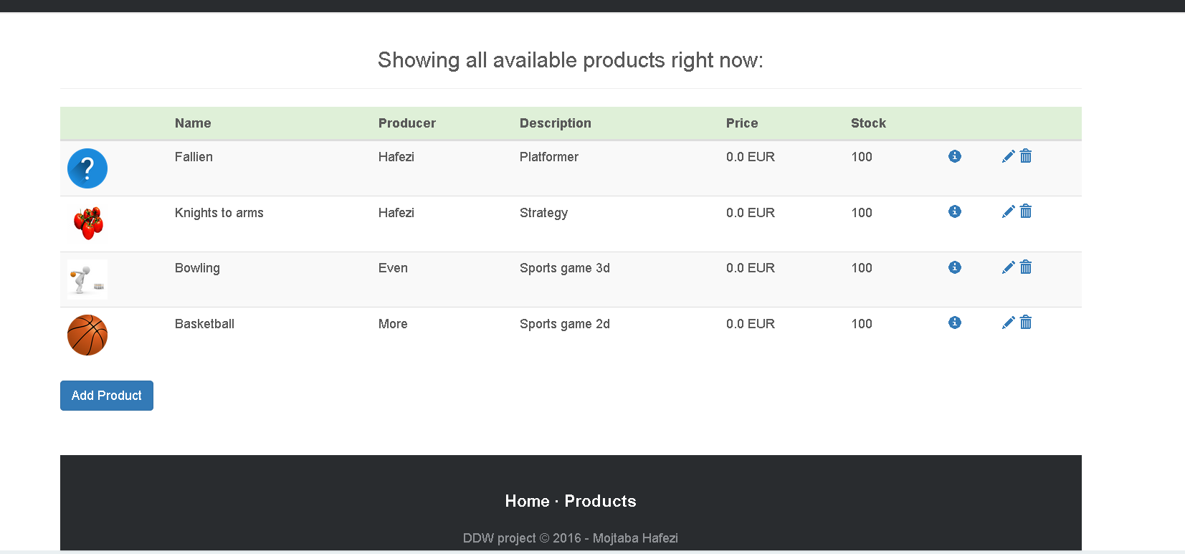

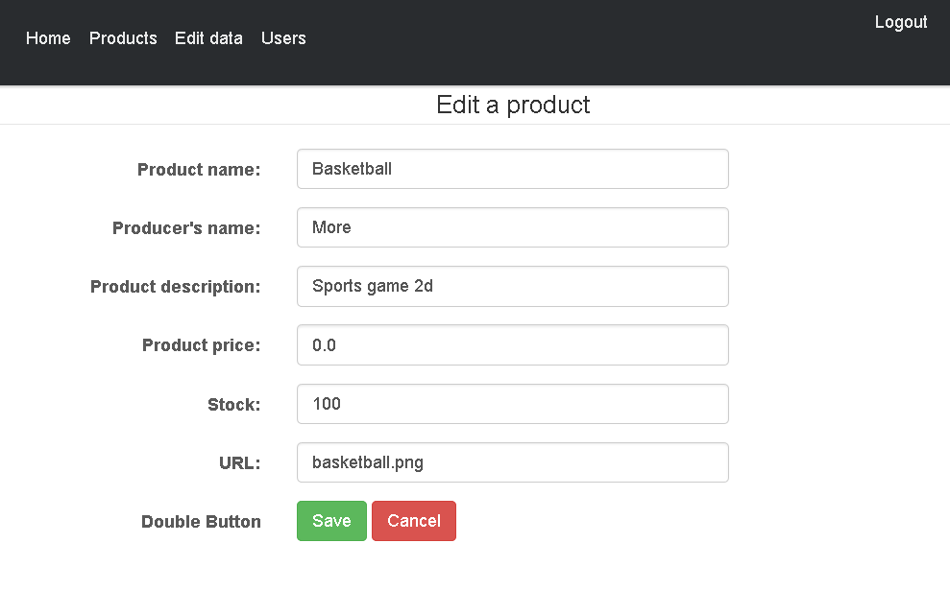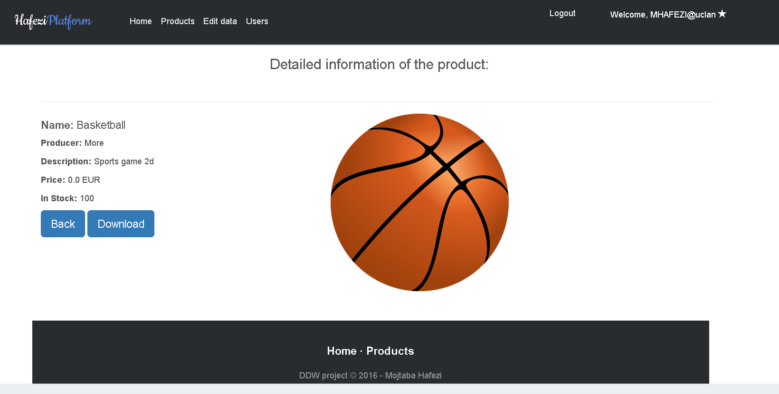

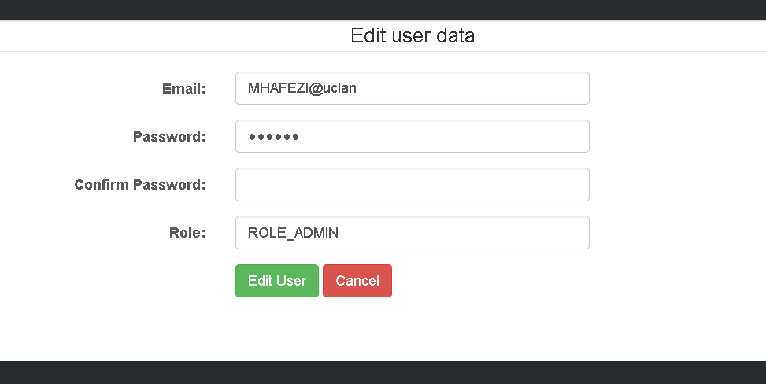

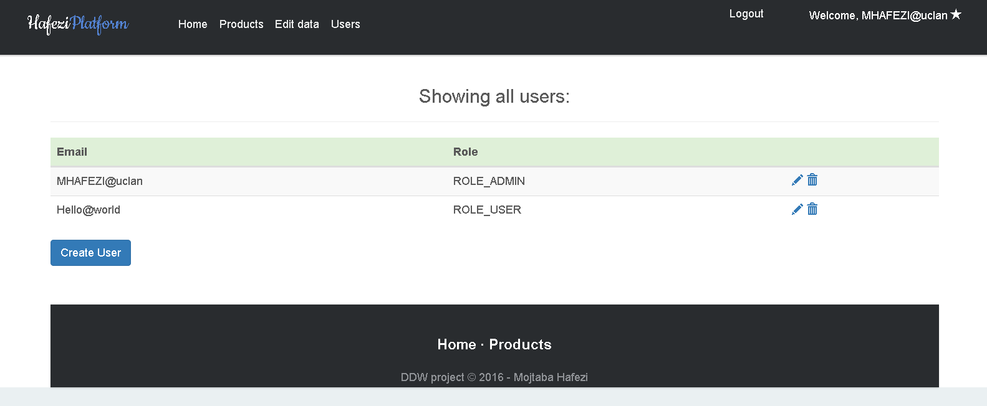

The last picture shows the project structure with the multi layered project structure.

